|  |  |
| --- | --- |
| SI NO  1  2  3  4  5  6  7  8 | TOPIC  ABSTRACT ABOUT THE PROJECT  ER DIAGRAM  SCHEMA  NORMALIZATION  -1 NF, 2NF, 3NF  DESCRIPTION OF ENTITIES AND SQL SYNTAX  SOURCE CODE  QUERIES  UPDATE AND TRIGGERS |

**INDEX**

**ABSTRACT**

In a world where crimes happen every second, it is important that the data about these crimes are stored. This stored data might help anyone at times; hence the crime database creation is necessary.

Once the FIR Number is entered the entire case details can be obtained which is of great help when a particular case is being searched.

Searching for particular cases which occurred during previous years are also helpful using a crime database which is provided with a front end GUI.

**DESCRIPTION ABOUT THE ENTITIES AND THEIR SQL SYNTAX:**

1. COMPLAINT: This table gives us information about the complaint such as complaint number, officer id, date of registration of the complaint, any value lost, location of the complaint lodged.

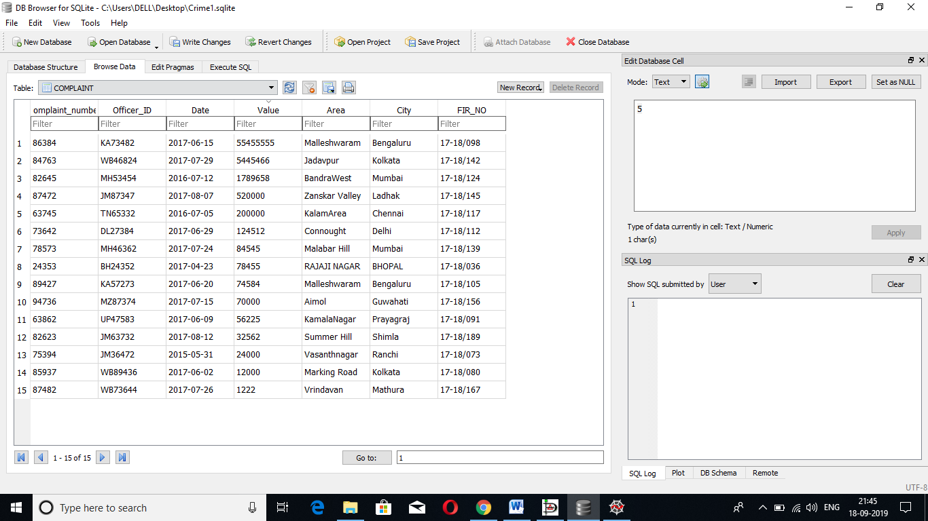

**SQL SYNTAX :** CREATE TABLE COMPLAINT (Complaint_number varchar(15) NOT NULL, Officer_ID varchar(12) NOT NULL, Date date NOT NULL, Value int,Area varchar(20),City varchar(20),FIR_NO VARCHAR(20));

1. OFFICER: This table gives us information about the officer details such as his rank, name, age, his ID, in a particular station.

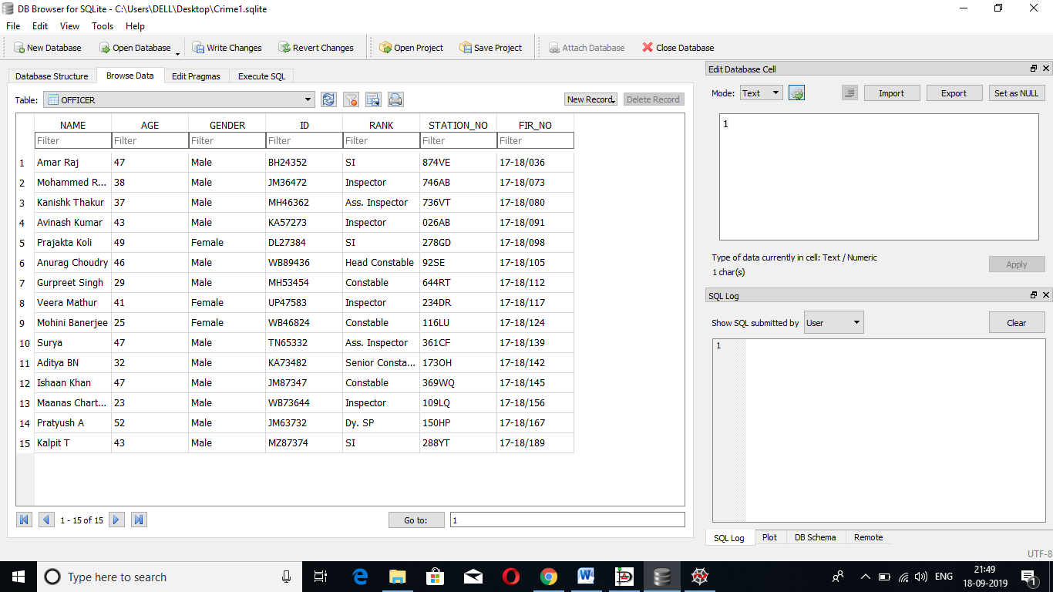

**SQL SYNTAX** : CREATE TABLE OFFICER (NAME VARCHAR(20) NOT NULL,AGE INT,GENDER VARCHAR(10),ID VARCHAR(20) NOT NULL,RANK VARCHAR(20),STATION_NO VARCHAR(20),FIR_NO VARCHAR(20));

1. COMPLAINANT: This table gives us information on the person who lodged the complaint such as their name, age, identification location also the FIR_NO relating to their case.

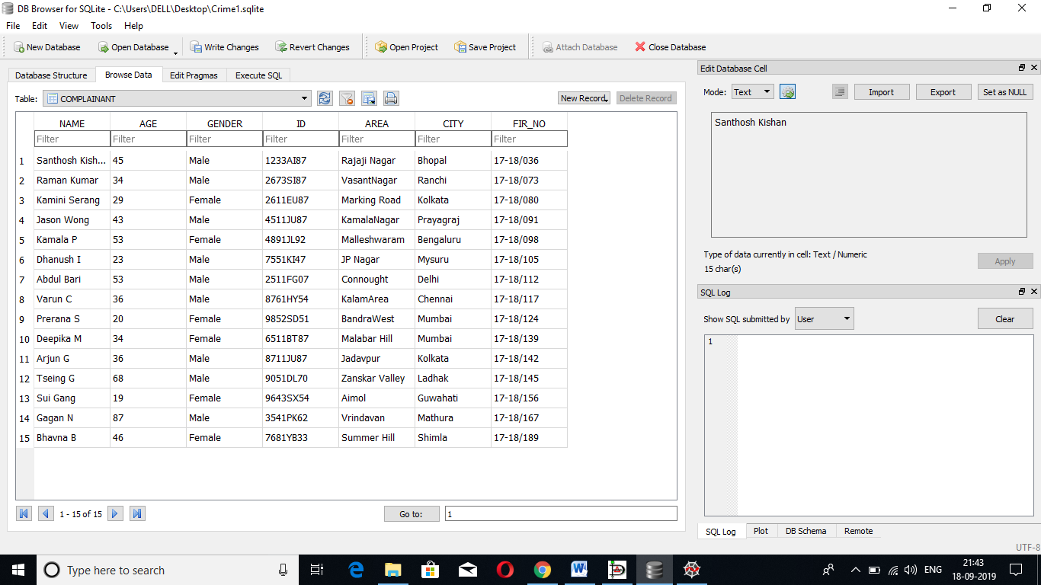

**SQL SYNTAX** : CREATE TABLE COMPLAINANT (NAME VARCHAR(20) NOT NULL,AGE INT,GENDER VARCHAR(10),ID VARCHAR(20) NOT NULL,AREA VARCHAR(20),CITY VARCHAR(20),FIR_NO VARCHAR(20));

1. CONVICTED: This table gives us information about the person convicted for a particular crime he/she committed. It gives the name, height, phone number, identification details, location and the FIR_NO for the case they are being convicted for.

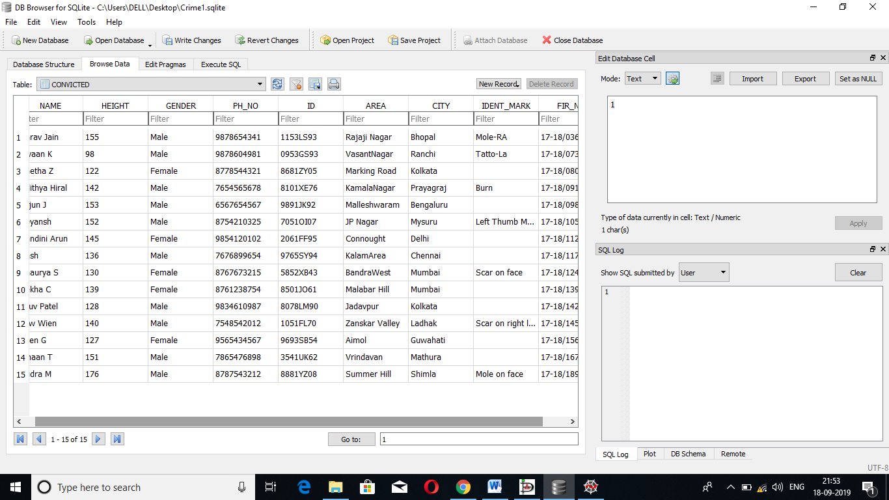

**SQL SYNTAX** : CREATE TABLE CONVICTED (NAME VARCHAR(20) NOT NULL,HEIGHT INT,GENDER VARCHAR(10),PH_NO VARCHAR(20),ID VARCHAR(20) NOT NULL,AREA VARCHAR(20),CITY VARCHAR(20),IDENT_MARK VARCHAR(20),FIR_NO VARCHAR(20) NOT NULL);

1. WITNESS: This table gives us information about the witness relating to the particular case including their name , age , identification details , phone number , location , their relation to the victim if any also the FIR_NO pertaining to the case for which they are a witness.

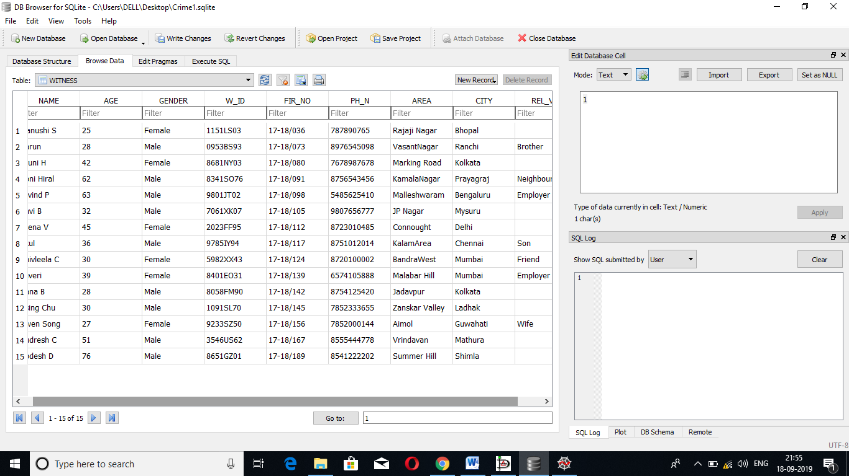

**SQL SYNTAX** : CREATE TABLE WITNESS (NAME VARCHAR(20) NOT NULL,AGE INT,GENDER VARCHAR(20),W_ID VARCHAR(20) NOT NULL,FIR_NO VARCHAR(20) NOT NULL,PH_N VARCHAR(20),AREA VARCHAR(20),CITY VARCHAR(20),REL_VIC VARCHAR(20));

1. COURT: This table gives us information about the court type , FIR_No, Defence Attorney, Public Prosecutor assigned to that case and also the judge for that case.

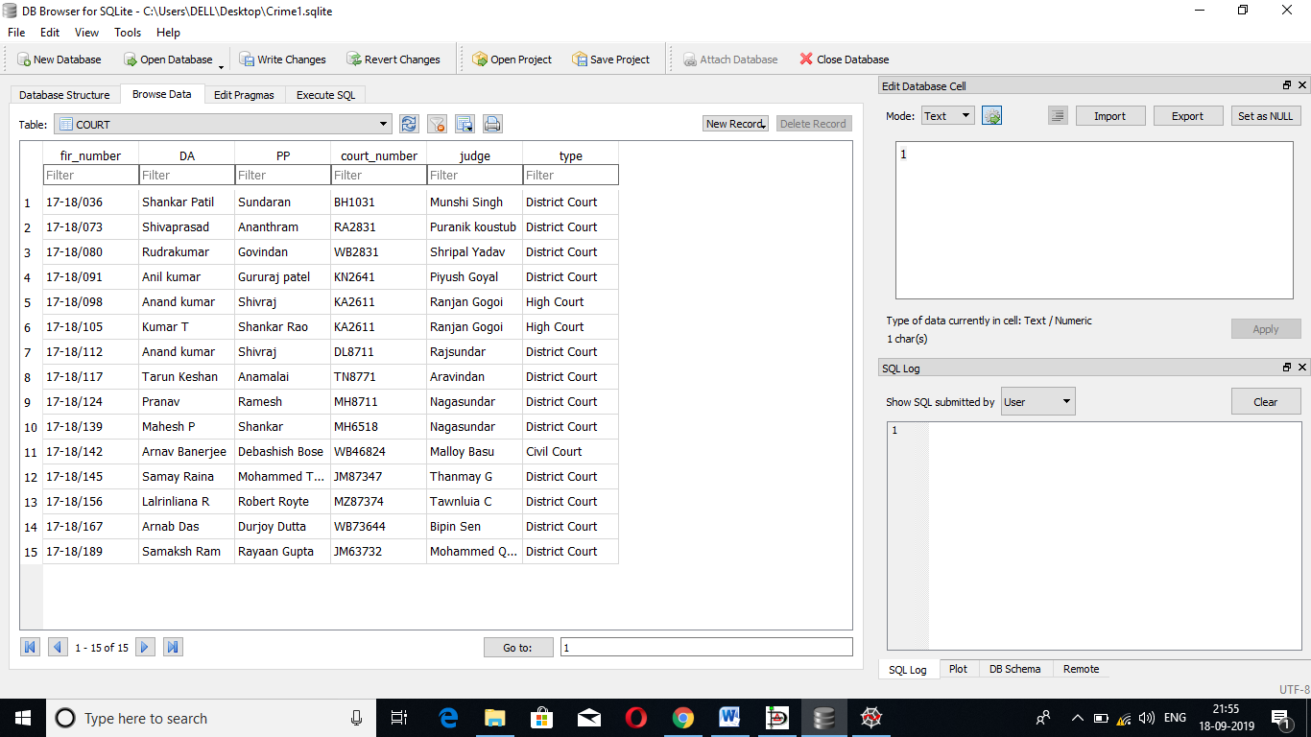

SQL SYNTAX : CREATE TABLE COURT (fir_number varchar(8) NOT NULL,DA varchar(20) NOT NULL,PP varchar(20) NOT NULL,court_number varchar(10) NOT NULL, judge varchar(20) NOT NULL, type varchar(20) NOT NULL);

1. PROOF: This table gives us information about the proof such as the proof_id, type of proof, the officer ID of the officer who collected the proof; the FIR_NO to relate to which case it is a proof.



**SQL SYNTAX**: CREATE TABLE PROOF (Proof_id varchar (15) NOT NULL, Officer_id varchar (12) NOT NULL, fir_number varchar (8) NOT NULL, type varchar (20));

1. FIR: This table gives us information about the FIR lodged for that particular case, including the Complaint number, Officer_id who files the FIR, date of filing of the FIR, also section and act for the crime.

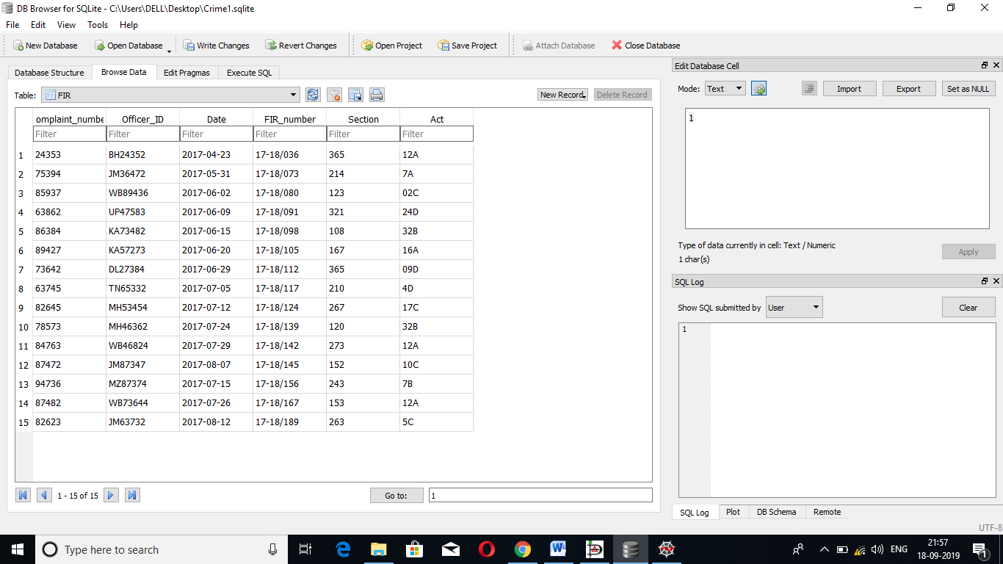

**SQL SYNTAX** : CREATE TABLE FIR (Complaint_number varchar(15) NOT NULL, Officer_ID varchar(12) NOT NULL, Date date NOT NULL,FIR_number varchar(8) NOT NULL,Section int NOT NULL, Act varchar(5) NOT NULL);

**SOURCE CODE**

**from** tkinter **import** *  
**import** tkinter **as** tk  
**from** tkinter **import** ttk  
**from** tkinter **import** messagebox  
**import** pandas **as** pd  
**from** tkcalendar **import** DateEntry  
**from** tkinter **import** *  
  
**import** sqlite3  
conn=sqlite3.connect(**'mydata.db'**)  
c=conn.cursor()  
*c.execute('''CREATE TABLE complainant modify column cname varchar(20) not null, modify column cage int not null, modify column cgender varchar(10) not null, modify column cid varchar(10) unique not null, modify column area varchar(20) not null, modify column city varchar(20) not null, modify column firno varchar(10) not null, FOREIGN KEY (firno) REFERENCES complaint(firno)''')  
#c.execute('''CREATE TABLE complainant modify cname varchar(20) not null,cage int not null, cgender varchar(10) not null,cid varchar(10) unique not null,area varchar(20) not null,city varchar(20) not null,firno varchar(10) not null, FOREIGN KEY (firno) REFERENCES complaint(firno)''')  
#c.execute('''CREATE TABLE convict modify coname varchar(20) not null ,coheight int not null ,cogen varchar(20) not null ,coph int(12) not null ,coid varchar(20) unique not null ,coiden varchar(25) not null ,firno varchar(10) not null , FOREIGN KEY (firno) REFERENCES complaint(firno)''')  
#c.execute('''CREATE TABLE officer modify offname varchar(20) not null ,offtype varchar(20) not null ,offid varchar(20) unique not null ,firno varchar(10) not null , FOREIGN KEY (firno) REFERENCES complaint(firno)''')  
#c.execute('''CREATE TABLE court modify courtda varchar(20) not null ,courtpp varchar(20) not null ,courtno varchar(20) not null ,courtjud varchar(20) not null ,courttype varchar(20) not null ,firno varchar(10) not null ,FOREIGN KEY (firno) REFERENCES complaint(firno)''')*root=Tk()  
root.configure(background=**'#A9A9A9'**)  
root.title(**"CRIMINAL DATABASE"**)  
root.iconbitmap(**'C:\\Users\\ruchi\\PycharmProjects\\namaskara\\img3.ico'**)  
filename = PhotoImage(file = **"C:\\Users\\ruchi\\PycharmProjects\\namaskara\\img2.png"**)  
background_label = Label(root,image=filename)  
label_0 = Label(root, text=**"W E L C O M E"**, font=(**"bold"**, 20),bg=**'#FF4500'**)  
background_label.pack()  
**def** query():  
  
  
 *'''q_root=Tk()  
 q_root.iconbitmap('C:\\Users\\ruchi\\PycharmProjects\\namaskara\\img3.ico')  
 q_root.geometry('700x700')  
 submit_but1 = Button(q_root, text=" QUERY 1", padx=45, relief=RAISED, command=q1submit)  
 submit_but1.grid(row=1, column=0)  
 submit_but1.configure(bg='green')  
 submit_but2 = Button(q_root, text=" QUERY 2", padx=45, relief=RAISED, command=q2submit)  
 submit_but2.grid(row=2, column=0)  
 submit_but2.configure(bg='green')  
 submit_but3 = Button(q_root, text=" QUERY 3", padx=45, relief=RAISED, command=q3submit)  
 submit_but3.grid(row=3, column=0)  
 submit_but3.configure(bg='green')  
 submit_but4 = Button(q_root, text=" QUERY 4", padx=45, relief=RAISED, command=q4submit)  
 submit_but4.grid(row=4, column=0)  
 submit_but4.configure(bg='green')  
 submit_but5 = Button(q_root, text=" QUERY 5", padx=45, relief=RAISED, command=q5submit)  
 submit_but5.grid(row=5, column=0)  
 submit_but5.configure(bg='green')  
 submit_but6 = Button(q_root, text=" QUERY 6", padx=45, relief=RAISED, command=q6submit)  
 submit_but6.grid(row=6, column=0)  
 submit_but6.configure(bg='green')  
 submit_but7 = Button(q_root, text=" QUERY 7", padx=45, relief=RAISED, command=q7submit)  
 submit_but7.grid(row=7, column=0)  
 submit_but7.configure(bg='green')  
 submit_but8 = Button(q_root, text=" QUERY 8", padx=45, relief=RAISED, command=q8submit)  
 submit_but8.grid(row=8, column=0)  
 submit_but8.configure(bg='green')  
 submit_but9 = Button(q_root, text=" QUERY 9", padx=45, relief=RAISED, command=q9submit)  
 submit_but9.grid(row=9, column=0)  
 submit_but9.configure(bg='green')  
 submit_but10 = Button(q_root, text="QUERY 10", padx=45, relief=RAISED, command=q10submit)  
 submit_but10.grid(row=10, column=0)  
 submit_but10.configure(bg='green')  
 submit_but11 = Button(q_root, text="QUERY 11", padx=45, relief=RAISED, command=q11submit)  
 submit_but11.grid(row=11, column=0)  
 submit_but11.configure(bg='green')  
 submit_but12 = Button(q_root, text="QUERY 12", padx=45, relief=RAISED, command=q12submit)  
 submit_but12.grid(row=12, column=0)  
 submit_but12.configure(bg='green')  
 submit_but13 = Button(q_root, text="QUERY 13", padx=45, relief=RAISED, command=q13submit)  
 submit_but13.grid(row=13, column=0)  
 submit_but13.configure(bg='green')  
 submit_but14 = Button(q_root, text="QUERY 14", padx=45, relief=RAISED, command=q14submit)  
 submit_but14.grid(row=14, column=0)  
 submit_but14.configure(bg='green')  
 submit_but15 = Button(q_root, text="QUERY 15", padx=45, relief=RAISED, command=q15submit)  
 submit_but15.grid(row=15, column=0)  
 submit_but15.configure(bg='green')  
 submit_but16 = Button(q_root, text="QUERY 16", padx=45, relief=RAISED, command=q16submit)  
 submit_but16.grid(row=16, column=0)  
 submit_but16.configure(bg='green')  
 submit_but17 = Button(q_root, text="QUERY 17", padx=45, relief=RAISED, command=q17submit)  
 submit_but17.grid(row=17, column=0)  
 submit_but17.configure(bg='green')  
 submit_but18= Button(q_root, text="QUERY 18", padx=45, relief=RAISED, command=q18submit)  
 submit_but18.grid(row=18, column=0)  
 submit_but18.configure(bg='green')  
 submit_but19 = Button(q_root, text="QUERY 19", padx=45, relief=RAISED, command=q19submit)  
 submit_but19.grid(row=19, column=0)  
 submit_but19.configure(bg='green')  
 submit_but20 = Button(q_root, text="QUERY 20", padx=45, relief=RAISED, command=q20submit)  
 submit_but20.grid(row=20, column=0)  
 submit_but20.configure(bg='green')'''* conn = sqlite3.connect(**'mydata.db'**)  
 c = conn.cursor()  
 root = Tk()  
 root.configure(background=**'#A9A9A9'**)  
 root.title(**"CRIMINAL DATABASE"**)  
  
 root.geometry(**"807x779+650+150"**)  
 root.title(**"Queries page"**)  
 root.configure(background=**"#c0cece"**)  
  
 root.geometry(**"807x779+650+150"**)  
 root.title(**"New rootlevel"**)  
 root.configure(background=**"#c0cece"**)  
  
 heading_frame = tk.Frame(root)  
 heading_frame.place(relx=0.025, rely=0.013, relheight=0.109, relwidth=0.96)  
  
 heading_frame.configure(relief=**'groove'**)  
 heading_frame.configure(borderwidth=**"2"**)  
 heading_frame.configure(relief=**"groove"**)  
 heading_frame.configure(background=**"#4651af"**)  
  
 heading_label = tk.Label(heading_frame)  
 heading_label.place(relx=0.103, rely=0.235, height=56, width=622)  
 heading_label.configure(activebackground=**"#c0cece"**)  
 heading_label.configure(background=**"#4651af"**)  
 heading_label.configure(borderwidth=**"3"**)  
 heading_label.configure(disabledforeground=**"#a3a3a3"**)  
 heading_label.configure(font=**"TkHeadingFont"**)  
 heading_label.configure(foreground=**"#000000"**)  
 heading_label.configure(highlightcolor=**"#7aafad"**)  
 heading_label.configure(text=**'''QUERIES'''**)  
  
 *# menubar = tk.Menu(root,font="TkMenuFont",bg=_bgcolor,fg=_fgcolor)  
 # root.configure(menu = menubar)* main_frame = tk.Frame(root)  
 main_frame.place(relx=0.012, rely=0.205, relheight=0.687  
 , relwidth=0.973)  
 main_frame.configure(relief=**'groove'**)  
 main_frame.configure(borderwidth=**"2"**)  
 main_frame.configure(relief=**"groove"**)  
 main_frame.configure(background=**"#becbd8"**)  
  
 **def** retq1():  
 conn = sqlite3.connect(**'mydata.db'**)  
 c = conn.cursor()  
  
 c.execute(  
 **'''Select * from convict where firno = "18-19/288"'''**)  
 rows = c.fetchall()  
 **global** temp_list  
 temp_list = []  
 **for** i **in** rows:  
 x = 0  
 **while** (x < 7):  
 temp_list.append(i[x])  
 x = x + 1  
 *# print(temp_list)* messagebox.showinfo(**"Convicted daetails with FIR np. 18-19/288 "**, temp_list)  
 **del** temp_list  
 conn.close()  
 **return** query_button1 = tk.Button(main_frame)  
 query_button1.place(relx=0.013, rely=0.019, height=43, width=366)  
 query_button1.configure(activebackground=**"#ececec"**)  
 query_button1.configure(activeforeground=**"#000000"**)  
 query_button1.configure(background=**"#6693d8"**)  
 query_button1.configure(disabledforeground=**"#a3a3a3"**)  
 query_button1.configure(foreground=**"#000000"**)  
 query_button1.configure(highlightbackground=**"#d9d9d9"**)  
 query_button1.configure(highlightcolor=**"black"**)  
 query_button1.configure(pady=**"0"**)  
 query_button1.configure(text=**'''CONVICTED DETAILS ARE'''**)  
 query_button1.configure(command=retq1)  
  
 **def** retq2():  
 conn = sqlite3.connect(**'mydata.db'**)  
 c = conn.cursor()  
  
 c.execute(  
 **'''Select cname from complainant where area = "Vijayanagar"'''**)  
 rows = c.fetchall()  
 **global** temp_list  
 temp_list = []  
 **for** i **in** rows:  
 x = 0  
 **while** (x < 1):  
 temp_list.append(i[x])  
 x = x + 1  
 *# print(temp_list)* messagebox.showinfo(**"Complainants from Vijayanagar "**, temp_list)  
 **del** temp_list  
 conn.close()  
 **return** query_button2 = tk.Button(main_frame)  
 query_button2.place(relx=0.013, rely=0.112, height=43, width=366)  
 query_button2.configure(activebackground=**"#ececec"**)  
 query_button2.configure(activeforeground=**"#000000"**)  
 query_button2.configure(background=**"#6693d8"**)  
 query_button2.configure(disabledforeground=**"#a3a3a3"**)  
 query_button2.configure(foreground=**"#000000"**)  
 query_button2.configure(highlightbackground=**"#d9d9d9"**)  
 query_button2.configure(highlightcolor=**"black"**)  
 query_button2.configure(pady=**"0"**)  
 query_button2.configure(text=**'''RETRIEVE COMPLAINANT NAMES FROM A PARTICULAR AREA'''**)  
 query_button2.configure(command=retq2)  
  
 **def** retq3():  
 conn = sqlite3.connect(**'mydata.db'**)  
 c = conn.cursor()  
  
 c.execute(  
 **'''Select coname from convict where cogen = "Female"'''**)  
 rows = c.fetchall()  
 **global** temp_list  
 temp_list = []  
 **for** i **in** rows:  
 x = 0  
 **while** (x < 7):  
 temp_list.append(i[x])  
 x = x + 1  
 *# print(temp_list)* messagebox.showinfo(**"All female convicts "**, temp_list)  
 **del** temp_list  
 conn.close()  
 **return** query_button3 = tk.Button(main_frame)  
 query_button3.place(relx=0.013, rely=0.206, height=43, width=366)  
 query_button3.configure(activebackground=**"#ececec"**)  
 query_button3.configure(activeforeground=**"#000000"**)  
 query_button3.configure(background=**"#6693d8"**)  
 query_button3.configure(disabledforeground=**"#a3a3a3"**)  
 query_button3.configure(foreground=**"#000000"**)  
 query_button3.configure(highlightbackground=**"#d9d9d9"**)  
 query_button3.configure(highlightcolor=**"black"**)  
 query_button3.configure(pady=**"0"**)  
 query_button3.configure(text=**'''RETRIEVE ALL FEMALE CONVICTS REGISTERED'''**)  
 query_button3.configure(command=retq3)  
  
 **def** retq4():  
 conn = sqlite3.connect(**'mydata.db'**)  
 c = conn.cursor()  
  
 c.execute(  
 **'''Select * from officer where firno = "18-19/788"'''**)  
 rows = c.fetchall()  
 **global** temp_list  
 temp_list = []  
 **for** i **in** rows:  
 x = 0  
 **while** (x < 7):  
 temp_list.append(i[x])  
 x = x + 1  
 *# print(temp_list)* messagebox.showinfo(**"Officer details handling case FIR no 18-19/788 "**, temp_list)  
 **del** temp_list  
 conn.close()  
 **return** query_button4 = tk.Button(main_frame)  
 query_button4.place(relx=0.013, rely=0.299, height=43, width=366)  
 query_button4.configure(activebackground=**"#ececec"**)  
 query_button4.configure(activeforeground=**"#000000"**)  
 query_button4.configure(background=**"#6693d8"**)  
 query_button4.configure(disabledforeground=**"#a3a3a3"**)  
 query_button4.configure(foreground=**"#000000"**)  
 query_button4.configure(highlightbackground=**"#d9d9d9"**)  
 query_button4.configure(highlightcolor=**"black"**)  
 query_button4.configure(pady=**"0"**)  
 query_button4.configure(text=**'''RETRIEVE OFFICER DETAILS HANDLING A PARTICULAR CASE'''**)  
 query_button4.configure(command=retq4)  
  
 **def** retq5():  
 conn = sqlite3.connect(**'mydata.db'**)  
 c = conn.cursor()  
  
 c.execute(  
 **'''Select courtjud from court where firno = "18-19/288"'''**)  
 rows = c.fetchall()  
 **global** temp_list  
 temp_list = []  
 **for** i **in** rows:  
 x = 0  
 **while** (x < 1):  
 temp_list.append(i[x])  
 x = x + 1  
 *# print(temp_list)* messagebox.showinfo(**"Judege for case with FIR no 18-19/288 "**, temp_list)  
 **del** temp_list  
 conn.close()  
 **return** query_button5 = tk.Button(main_frame)  
 query_button5.place(relx=0.013, rely=0.393, height=43, width=366)  
 query_button5.configure(activebackground=**"#ececec"**)  
 query_button5.configure(activeforeground=**"#000000"**)  
 query_button5.configure(background=**"#6693d8"**)  
 query_button5.configure(disabledforeground=**"#a3a3a3"**)  
 query_button5.configure(foreground=**"#000000"**)  
 query_button5.configure(highlightbackground=**"#d9d9d9"**)  
 query_button5.configure(highlightcolor=**"black"**)  
 query_button5.configure(pady=**"0"**)  
 query_button5.configure(text=**'''RETRIEVE JUDGE NAME FOR GIVEN FIR No.'''**)  
 query_button5.configure(command=retq5)  
  
 **def** retq6():  
 conn = sqlite3.connect(**'mydata.db'**)  
 c = conn.cursor()  
  
 c.execute(  
 **'''Select prooftype from complaint where proofid = "254365"'''**)  
 rows = c.fetchall()  
 **global** temp_list  
 temp_list = []  
 **for** i **in** rows:  
 x = 0  
 **while** (x < 1):  
 temp_list.append(i[x])  
 x = x + 1  
 *# print(temp_list)* messagebox.showinfo(**"Proof type with proof ID 254365 "**, temp_list)  
 **del** temp_list  
 conn.close()  
 **return** query_button6 = tk.Button(main_frame)  
 query_button6.place(relx=0.013, rely=0.486, height=43, width=366)  
 query_button6.configure(activebackground=**"#ececec"**)  
 query_button6.configure(activeforeground=**"#000000"**)  
 query_button6.configure(background=**"#6693d8"**)  
 query_button6.configure(disabledforeground=**"#a3a3a3"**)  
 query_button6.configure(foreground=**"#000000"**)  
 query_button6.configure(highlightbackground=**"#d9d9d9"**)  
 query_button6.configure(highlightcolor=**"black"**)  
 query_button6.configure(pady=**"0"**)  
 query_button6.configure(text=**'''RETRIEVE PROOF TYPE FOR GIVEN PROOF ID'''**)  
 query_button6.configure(command=retq6)  
  
 **def** retq7():  
 conn = sqlite3.connect(**'mydata.db'**)  
 c = conn.cursor()  
  
 c.execute(  
 **'''Select courtpp from court where courtda = "Aisiri"'''**)  
 rows = c.fetchall()  
 **global** temp_list  
 temp_list = []  
 **for** i **in** rows:  
 x = 0  
 **while** (x < 1):  
 temp_list.append(i[x])  
 x = x + 1  
 *# print(temp_list)* messagebox.showinfo(**"PP where DA = Aisiri is "**, temp_list)  
 **del** temp_list  
 conn.close()  
 **return** query_button7 = tk.Button(main_frame)  
 query_button7.place(relx=0.013, rely=0.766, height=43, width=366)  
 query_button7.configure(activebackground=**"#ececec"**)  
 query_button7.configure(activeforeground=**"#000000"**)  
 query_button7.configure(background=**"#6693d8"**)  
 query_button7.configure(disabledforeground=**"#a3a3a3"**)  
 query_button7.configure(foreground=**"#000000"**)  
 query_button7.configure(highlightbackground=**"#d9d9d9"**)  
 query_button7.configure(highlightcolor=**"black"**)  
 query_button7.configure(pady=**"0"**)  
 query_button7.configure(text=**'''RETRIEVE PP WHERE DA IS GIVEN'''**)  
 query_button7.configure(command=retq7)  
  
 **def** retq8():  
 conn = sqlite3.connect(**'mydata.db'**)  
 c = conn.cursor()  
  
 c.execute(  
 **'''Select coname from convict where coheight > 160'''**)  
 rows = c.fetchall()  
 **global** temp_list  
 temp_list = []  
 **for** i **in** rows:  
 x = 0  
 **while** (x < 7):  
 temp_list.append(i[x])  
 x = x + 1  
 *# print(temp_list)* messagebox.showinfo(**"Convicts taller than 160cm "**, temp_list)  
 **del** temp_list  
 conn.close()  
 **return** query_button8 = tk.Button(main_frame)  
 query_button8.place(relx=0.013, rely=0.579, height=43, width=366)  
 query_button8.configure(activebackground=**"#ececec"**)  
 query_button8.configure(activeforeground=**"#000000"**)  
 query_button8.configure(background=**"#6693d8"**)  
 query_button8.configure(disabledforeground=**"#a3a3a3"**)  
 query_button8.configure(foreground=**"#000000"**)  
 query_button8.configure(highlightbackground=**"#d9d9d9"**)  
 query_button8.configure(highlightcolor=**"black"**)  
 query_button8.configure(pady=**"0"**)  
 query_button8.configure(text=**'''RETRIEVE CONVICTS TALLER THAN GIVEN HEIGHT'''**)  
 query_button8.configure(command=retq8)  
  
 **def** retq9():  
 conn = sqlite3.connect(**'mydata.db'**)  
 c = conn.cursor()  
  
 c.execute(  
 **'''Select witname from complaint where firno = "18-19/788" '''**)  
 rows = c.fetchall()  
 **global** temp_list  
 temp_list = []  
 **'''for i in rows:  
 x = 0  
 while (x < 1):  
 temp_list.append(i[x])  
 x = x + 1'''** *# print(temp_list)* messagebox.showinfo(**"Witness for FIR No. 18-19/788 is "**, temp_list)  
 **del** temp_list  
 conn.close()()  
 **return** query_button9 = tk.Button(main_frame)  
 query_button9.place(relx=0.013, rely=0.673, height=43, width=366)  
 query_button9.configure(activebackground=**"#ececec"**)  
 query_button9.configure(activeforeground=**"#000000"**)  
 query_button9.configure(background=**"#6693d8"**)  
 query_button9.configure(disabledforeground=**"#a3a3a3"**)  
 query_button9.configure(foreground=**"#000000"**)  
 query_button9.configure(highlightbackground=**"#d9d9d9"**)  
 query_button9.configure(highlightcolor=**"black"**)  
 query_button9.configure(pady=**"0"**)  
 query_button9.configure(text=**'''RETRIEVE WITNESS FOR GIVEN FIR No.'''**)  
 query_button9.configure(command=retq9)  
  
 **def** retq10():  
 conn = sqlite3.connect(**'mydata.db'**)  
 c = conn.cursor()  
  
 c.execute(  
 **'''Select offname from officer where offid = "245375"'''**)  
 rows = c.fetchall()  
 **global** temp_list  
 temp_list = []  
 **for** i **in** rows:  
 x = 0  
 **while** (x < 1):  
 temp_list.append(i[x])  
 x = x + 1  
 *# print(temp_list)* messagebox.showinfo(**"Officer with ID = 245375 "**, temp_list)  
 **del** temp_list  
 conn.close()  
 **return** query_button10 = tk.Button(main_frame)  
 query_button10.place(relx=0.013, rely=0.86, height=43, width=366)  
 query_button10.configure(activebackground=**"#ececec"**)  
 query_button10.configure(activeforeground=**"#000000"**)  
 query_button10.configure(background=**"#6693d8"**)  
 query_button10.configure(disabledforeground=**"#a3a3a3"**)  
 query_button10.configure(foreground=**"#000000"**)  
 query_button10.configure(highlightbackground=**"#d9d9d9"**)  
 query_button10.configure(highlightcolor=**"black"**)  
 query_button10.configure(pady=**"0"**)  
 query_button10.configure(text=**'''RETRIEVE OFFICER WITH GIVEN ID '''**)  
 query_button10.configure(command=retq10)  
  
 **def** retq11():  
 conn = sqlite3.connect(**'mydata.db'**)  
 c = conn.cursor()  
  
 c.execute(  
 **'''Select courttype from court where courtno = "KA341"'''**)  
 rows = c.fetchall()  
 **global** temp_list  
 temp_list = []  
 **for** i **in** rows:  
 x = 0  
 **while** (x < 1):  
 temp_list.append(i[x])  
 x = x + 1  
 *# print(temp_list)* messagebox.showinfo(**"Court type with courtnumber=KA341 "**, temp_list)  
 **del** temp_list  
 conn.close()  
 **return** query_button11 = tk.Button(main_frame)  
 query_button11.place(relx=0.548, rely=0.019, height=43, width=336)  
 query_button11.configure(activebackground=**"#ececec"**)  
 query_button11.configure(activeforeground=**"#000000"**)  
 query_button11.configure(background=**"#6693d8"**)  
 query_button11.configure(disabledforeground=**"#a3a3a3"**)  
 query_button11.configure(foreground=**"#000000"**)  
 query_button11.configure(highlightbackground=**"#d9d9d9"**)  
 query_button11.configure(highlightcolor=**"black"**)  
 query_button11.configure(pady=**"0"**)  
 query_button11.configure(text=**'''GET THE COURT DETAILS FOR GIVEN COURT ID'''**)  
 query_button11.configure(command=retq11)  
  
 **def** retq12():  
 conn = sqlite3.connect(**'mydata.db'**)  
 c = conn.cursor()  
  
 c.execute(  
 **'''Select C.coname, P.area from convict as C, complainant as P where P.city = "Mysuru" '''**)  
 rows = c.fetchall()  
 **global** temp_list  
 temp_list = []  
 **for** i **in** rows:  
 x = 0  
 *# while (x < 1):* temp_list.append(i)  
 *# x = x + 1  
 # print(temp_list)* messagebox.showinfo(**"Convictname and area in Mysuru"**, temp_list)  
 **del** temp_list  
 conn.close()  
 **return** query_button12 = tk.Button(main_frame)  
 query_button12.place(relx=0.548, rely=0.112, height=43, width=336)  
 query_button12.configure(activebackground=**"#ececec"**)  
 query_button12.configure(activeforeground=**"#000000"**)  
 query_button12.configure(background=**"#6693d8"**)  
 query_button12.configure(disabledforeground=**"#a3a3a3"**)  
 query_button12.configure(foreground=**"#000000"**)  
 query_button12.configure(highlightbackground=**"#d9d9d9"**)  
 query_button12.configure(highlightcolor=**"black"**)  
 query_button12.configure(pady=**"0"**)  
 query_button12.configure(text=**'''CONVICTS NAME AND AREA IN MYSURU'''**)  
 query_button12.configure(command=retq12)  
  
 **def** retq13():  
 conn = sqlite3.connect(**'mydata.db'**)  
 c = conn.cursor()  
  
 c.execute(  
 **'''Select coname from convict where coheight= "165"'''**)  
 rows = c.fetchall()  
 **global** temp_list  
 temp_list = []  
 **for** i **in** rows:  
 x = 0  
 **while** (x < 1):  
 temp_list.append(i[x])  
 x = x + 1  
 *# print(temp_list)* messagebox.showinfo(**"Convictname with height 165cms "**, temp_list)  
 **del** temp_list  
 conn.close()  
 **return** query_button13 = tk.Button(main_frame)  
 query_button13.place(relx=0.548, rely=0.206, height=43, width=336)  
 query_button13.configure(activebackground=**"#ececec"**)  
 query_button13.configure(activeforeground=**"#000000"**)  
 query_button13.configure(background=**"#6693d8"**)  
 query_button13.configure(disabledforeground=**"#a3a3a3"**)  
 query_button13.configure(foreground=**"#000000"**)  
 query_button13.configure(highlightbackground=**"#d9d9d9"**)  
 query_button13.configure(highlightcolor=**"black"**)  
 query_button13.configure(pady=**"0"**)  
 query_button13.configure(text=**'''CONVICTS NAME AND AREA WHO ARE OF 165CMS HEIGHT'''**)  
 query_button13.configure(command=retq13)  
  
 **def** retq14():  
 conn = sqlite3.connect(**'mydata.db'**)  
 c = conn.cursor()  
  
 c.execute(  
 **'''Select sum(comval),area from complaint C,complainant R where in R.city = "Bengaluru"'''**)  
 rows = c.fetchall()  
 **global** temp_list  
 temp_list = []  
 **for** i **in** rows:  
 x = 0  
 **while** (x < 1):  
 temp_list.append(i[x])  
 x = x + 1  
 *# print(temp_list)* messagebox.showinfo(**"Total value lost during crime in Benagluru"**, temp_list)  
 **del** temp_list  
 conn.close()  
 **return** query_button14 = tk.Button(main_frame)  
 query_button14.place(relx=0.548, rely=0.299, height=43, width=336)  
 query_button14.configure(activebackground=**"#ececec"**)  
 query_button14.configure(activeforeground=**"#000000"**)  
 query_button14.configure(background=**"#6693d8"**)  
 query_button14.configure(disabledforeground=**"#a3a3a3"**)  
 query_button14.configure(foreground=**"#000000"**)  
 query_button14.configure(highlightbackground=**"#d9d9d9"**)  
 query_button14.configure(highlightcolor=**"black"**)  
 query_button14.configure(pady=**"0"**)  
 query_button14.configure(text=**'''TOTAL VALUE LOST DURING CRIME IN BENGALURU'''**)  
 query_button14.configure(command=retq14)  
  
 **def** retq15():  
 conn = sqlite3.connect(**'mydata.db'**)  
 c = conn.cursor()  
  
 c.execute(  
 **'''Select COUNT(*) from complainant where city= "Kurnool and complaint.date=2017%"'''**)  
 rows = c.fetchall()  
 **global** temp_list  
 temp_list = []  
 **for** i **in** rows:  
 x = 0  
 **while** (x < 1):  
 temp_list.append(i[x])  
 x = x + 1  
 *# print(temp_list)* messagebox.showinfo(**"Complaint count in Kurnool in 2017"**, temp_list)  
 **del** temp_list  
 conn.close()  
 **return** query_button15 = tk.Button(main_frame)  
 query_button15.place(relx=0.548, rely=0.393, height=43, width=336)  
 query_button15.configure(activebackground=**"#ececec"**)  
 query_button15.configure(activeforeground=**"#000000"**)  
 query_button15.configure(background=**"#6693d8"**)  
 query_button15.configure(disabledforeground=**"#a3a3a3"**)  
 query_button15.configure(foreground=**"#000000"**)  
 query_button15.configure(highlightbackground=**"#d9d9d9"**)  
 query_button15.configure(highlightcolor=**"black"**)  
 query_button15.configure(pady=**"0"**)  
 query_button15.configure(text=**'''TOTAL NUMBER OF CRIMES REGISTERED IN KURNOOL IN 2017'''**)  
 query_button15.configure(command=retq15)  
  
 **return  
def** retrieve():  
 ret_root = Tk()  
 ret_root.geometry(**'700x700'**)  
 ret_root.title(**"RETRIEVE QUERIES"**)  
 ret_root.iconbitmap(**'C:\\Users\\ruchi\\PycharmProjects\\namaskara\\img3.ico'**)  
 Frame1 = tk.Frame(ret_root)  
 Frame1.place(relx=0.029, rely=0.06, relheight=0.261, relwidth=0.95)  
 Frame1.configure(relief=**'groove'**)  
 Frame1.configure(borderwidth=**"2"**)  
 Frame1.configure(relief=**"groove"**)  
 Frame1.configure(background=**"#d9d9d9"**)  
 *# print(i[0], i[1], i[2], i[3], i[4], i[5], i[6], i[7])* conn = sqlite3.connect(**'mydata.db'**)  
 compnum = conn.cursor()  
 compnum.execute(**'''select comnum from complaint '''**)  
 compnumr = compnum.fetchall()  
 **global** complist  
 complist = []  
 **for** i **in** compnumr:  
 complist.append(i)  
 *# print(complist)* var = StringVar(Frame1)  
 var.set(complist[0])  
 mynumber = tk.StringVar()  
 complist2=tuple(complist)  
 ret_complaint_no = ttk.Combobox(Frame1,textvariable=mynumber)  
 ret_complaint_no[**'values'**] = complist2  
 ret_complaint_no.place(relx=0.03, rely=0.229, height=40, relwidth=0.382)  
 print(ret_complaint_no.get())  
 conn.close()()  
 conn = sqlite3.connect(**'mydata.db'**)  
 firnum = conn.cursor()  
 firnum.execute(**'''select firno from complaint '''**)  
 firnumr = firnum.fetchall()  
 **global** firlist  
 firlist = []  
 **for** i **in** firnumr:  
 firlist.append(i)  
 *# print(complist)* var1 = StringVar(Frame1)  
 var1.set(firlist[0])  
 mynumber1 = tk.StringVar()  
 firlist2 = tuple(firlist)  
 ret_fir_no = ttk.Combobox(Frame1, textvariable=mynumber1)  
 ret_fir_no[**'values'**] = firlist2  
 ret_fir_no.place(relx=0.556, rely=0.229, height=40, relwidth=0.367)  
  
  
 ret_date = DateEntry(Frame1, width=12, year=2019, month=7, day=22,  
 background=**'darkblue'**, foreground=**'white'**, borderwidth=2)  
 ret_date.pack(padx=10, pady=10)  
 ret_date.place(relx=0.03, rely=0.629, height=40,  
 relwidth=0.382)  
  
 Label11 = tk.Label(Frame1)  
 conn.close()()  
 conn = sqlite3.connect(**'mydata.db'**)  
 city = conn.cursor()  
 city.execute(**'''select city from complainant '''**)  
 cityr = city.fetchall()  
 **global** citylist  
 citylist = []  
 **for** i **in** cityr:  
 citylist.append(i)  
 *# print(complist)* var2 = StringVar(Frame1)  
 var2.set(citylist[0])  
 mynumber2 = tk.StringVar()  
 citylist2 = tuple(citylist)  
 ret_city = ttk.Combobox(Frame1, textvariable=mynumber2)  
 ret_city[**'values'**] = citylist2  
 *#ret_city = tk.Entry(Frame1)* ret_city.place(relx=0.556, rely=0.629, height=40, relwidth=0.382)  
 ret_city.configure(background=**"white"**)  
 *#ret_city.configure(disabledforeground="#a3a3a3")  
 #ret_city.configure(font="TkFixedFont")  
 #ret_city.configure(foreground="#000000")* Label11.configure(background=**"#d9d9d9"**)  
 Label11.configure(disabledforeground=**"#a3a3a3"**)  
 Label11.configure(foreground=**"#000000"**)  
 Label11.configure(text=**'''COMPLAINT NUMBER'''**)  
  
 Label2 = tk.Label(Frame1)  
 Label2.place(relx=0.556, rely=0.057, height=21, width=73)  
 Label2.configure(background=**"#d9d9d9"**)  
 Label2.configure(disabledforeground=**"#a3a3a3"**)  
 Label2.configure(foreground=**"#000000"**)  
 Label2.configure(text=**'''FIR NUMBER'''**)  
  
 Label3 = tk.Label(Frame1)  
 Label3.place(relx=0.045, rely=0.514, height=11, width=34)  
 Label3.configure(background=**"#d9d9d9"**)  
 Label3.configure(disabledforeground=**"#a3a3a3"**)  
 Label3.configure(foreground=**"#000000"**)  
 Label3.configure(text=**'''DATE'''**)  
  
 Label4 = tk.Label(Frame1)  
 Label4.place(relx=0.571, rely=0.514, height=11, width=30)  
 Label4.configure(background=**"#d9d9d9"**)  
 Label4.configure(disabledforeground=**"#a3a3a3"**)  
 Label4.configure(foreground=**"#000000"**)  
 Label4.configure(text=**'''CITY'''**)  
  
 ret_con_name = tk.Entry(ret_root)  
 ret_con_name.place(relx=0.057, rely=0.403, height=40, relwidth=0.363)  
 ret_con_name.configure(background=**"white"**)  
 ret_con_name.configure(disabledforeground=**"#a3a3a3"**)  
 ret_con_name.configure(font=**"TkFixedFont"**)  
 ret_con_name.configure(foreground=**"#000000"**)  
 ret_con_name.configure(insertbackground=**"black"**)  
  
 Label5 = tk.Label(ret_root)  
 Label5.place(relx=0.071, rely=0.358, height=21, width=107)  
 Label5.configure(background=**"#d9d9d9"**)  
 Label5.configure(disabledforeground=**"#a3a3a3"**)  
 Label5.configure(foreground=**"#000000"**)  
 Label5.configure(text=**'''CONVICTED NAME'''**)  
  
 **def** Find():  
 print(ret_complaint_no.get())  
 conn = sqlite3.connect(**'mydata.db'**)  
 c = conn.cursor()  
  
 c.execute(  
 **'''select * from convict where firno = '{}' '''**.format(  
 ret_fir_no.get()))  
 c1=conn.cursor()  
 c1.execute(**'''select * from complainant where firno ='{}' '''**.format (ret_fir_no.get()))  
  
  
 **try**:  
 **def** pop():  
 rows = c.fetchall()  
 **global** temp_list  
 temp_list=[]  
 **for** i **in** rows:  
 x=0  
 **while** (x<=len(temp_list)):  
 temp_list.append(i[x])  
 x=x+1  
 print(temp_list)  
 messagebox._show(**"QUERIES FOUND"**, temp_list)  
 **del** temp_list[:]  
 pop()  
 conn.close()()  
  
 **except** IndexError:  
 messagebox.showerror(**"ERROR"**,**"No Value entered"**)  
  
  
 ret_root.destroy()  
 Button1 = tk.Button(ret_root, command=Find)  
 Button1.place(relx=0.6, rely=0.403, height=44, width=227)  
 Button1.configure(activebackground=**"#ececec"**)  
 Button1.configure(activeforeground=**"#000000"**)  
 Button1.configure(background=**"#d9d9d9"**)  
 Button1.configure(disabledforeground=**"#a3a3a3"**)  
 Button1.configure(foreground=**"#000000"**)  
 Button1.configure(highlightbackground=**"#d9d9d9"**)  
 Button1.configure(highlightcolor=**"black"**)  
 Button1.configure(pady=**"0"**)  
 Button1.configure(text=**'''SUBMIT'''**)  
  
 Label1 = tk.Label(Frame1)  
 Label1.place(relx=0.03, rely=0.057, height=21, width=124)  
 Label1.configure(background=**"#d9d9d9"**)  
 Label1.configure(disabledforeground=**"#a3a3a3"**)  
 Label1.configure(foreground=**"#000000"**)  
 Label1.configure(text=**'COMPLAINT NUMBER'**)  
 **return  
  
  
def** enter():  
 enter_root = Tk()  
 enter_root.iconbitmap(**'C:\\Users\\ruchi\\PycharmProjects\\namaskara\\img3.ico'**)  
 enter_root.title(**'Enter Crime Details'**)  
 b=StringVar(enter_root, value=**'0'**)  
 n=StringVar(enter_root,value=**'NULL'**)  
 l=StringVar(enter_root,value=**'NULL'**)  
 v=StringVar(enter_root,value=**'NULL'**)  
 e=StringVar(enter_root,value=**'MM/DD/YYYY'**)  
 c_name = Entry(enter_root, width=30)  
 c_name.grid(row=0, column=1, padx=20)  
 c_age = Entry(enter_root, width=30)  
 c_age.grid(row=1, column=1)  
 c_gender = Entry(enter_root, width=30)  
 c_gender.grid(row=2, column=1)  
 c_id = Entry(enter_root, width=30)  
 c_id.grid(row=3, column=1)  
 area = Entry(enter_root, width=30)  
 area.grid(row=4, column=1)  
 city = Entry(enter_root, width=30)  
 city.grid(row=5, column=1)  
 co_name = Entry(enter_root, width=30)  
 co_name.grid(row=6, column=1)  
 co_height = Entry(enter_root, width=30)  
 co_height.grid(row=7, column=1)  
 co_gen = Entry(enter_root, width=30)  
 co_gen.grid(row=8, column=1)  
 co_ph = Entry(enter_root, width=30)  
 co_ph.grid(row=9, column=1)  
 co_id = Entry(enter_root, width=30)  
 co_id.grid(row=10, column=1)  
 co_iden = Entry(enter_root, width=30,text=v)  
 co_iden.grid(row=11, column=1)  
 com_num = Entry(enter_root, width=30)  
 com_num.grid(row=12, column=1)  
 com_date = Entry(enter_root, width=30,text=e)  
 com_date.grid(row=13, column=1)  
 com_val = Entry(enter_root, width=30,text=b)  
 com_val.grid(row=14, column=1)  
 fir_no = Entry(enter_root, width=30)  
 fir_no.grid(row=0, column=4)  
 sec = Entry(enter_root, width=30)  
 sec.grid(row=1, column=4)  
 act = Entry(enter_root, width=30)  
 act.grid(row=2, column=4)  
 proof_type = Entry(enter_root, width=30,text=n)  
 proof_type.grid(row=3, column=4)  
 proof_id = Entry(enter_root, width=30,text=n)  
 proof_id.grid(row=4, column=4)  
 off_name = Entry(enter_root, width=30)  
 off_name.grid(row=5, column=4)  
 off_id = Entry(enter_root, width=30)  
 off_id.grid(row=6, column=4)  
 off_type = Entry(enter_root, width=30)  
 off_type.grid(row=7, column=4)  
 wit_name = Entry(enter_root, width=30,text=l)  
 wit_name.grid(row=8, column=4)  
 wit_age = Entry(enter_root, width=30,text=l)  
 wit_age.grid(row=9, column=4)  
 wit_gen = Entry(enter_root, width=30,text=l)  
 wit_gen.grid(row=10, column=4)  
 wit_ph = Entry(enter_root, width=30,text=l)  
 wit_ph.grid(row=11, column=4)  
 wit_rel = Entry(enter_root, width=30,text=l)  
 wit_rel.grid(row=12, column=4)  
 court_da = Entry(enter_root, width=30)  
 court_da.grid(row=13, column=4)  
 court_pp = Entry(enter_root, width=30)  
 court_pp.grid(row=14, column=4)  
 court_no = Entry(enter_root, width=30)  
 court_no.grid(row=15, column=1)  
 court_jud = Entry(enter_root, width=30)  
 court_jud.grid(row=16, column=1)  
 court_type = Entry(enter_root, width=30)  
 court_type.grid(row=17, column=1)  
 l1 = Label(enter_root, text=**" Complainant Name "**)  
 l1.grid(row=0, column=0)  
 l2 = Label(enter_root, text=**" Complainant Age "**)  
 l2.grid(row=1, column=0)  
 l3 = Label(enter_root, text=**" Gender "**)  
 l3.grid(row=2, column=0)  
 l4 = Label(enter_root, text=**" Complainant ID "**)  
 l4.grid(row=3, column=0)  
 l5 = Label(enter_root, text=**" Area "**)  
 l5.grid(row=4, column=0)  
 l6 = Label(enter_root, text=**" City "**)  
 l6.grid(row=5, column=0)  
 l7 = Label(enter_root, text=**" Convict Name "**)  
 l7.grid(row=6, column=0)  
 l8 = Label(enter_root, text=**" Height "**)  
 l8.grid(row=7, column=0)  
 l9 = Label(enter_root, text=**" Gender "**)  
 l9.grid(row=8, column=0)  
 l10 = Label(enter_root, text=**" Phone Number "**)  
 l10.grid(row=9, column=0)  
 l11 = Label(enter_root, text=**" ID "**)  
 l11.grid(row=10, column=0)  
 l12 = Label(enter_root, text=**" Identification "**)  
 l12.grid(row=11, column=0)  
 l13 = Label(enter_root, text=**" Complaint No. "**)  
 l13.grid(row=12, column=0)  
 l14 = Label(enter_root, text=**" DATE "**)  
 l14.grid(row=13, column=0)  
 l15 = Label(enter_root, text=**" Value Lost "**)  
 l15.grid(row=14, column=0)  
 l16 = Label(enter_root, text=**" FIR Number "**)  
 l16.grid(row=0, column=3)  
 l17 = Label(enter_root, text=**" Section "**)  
 l17.grid(row=1, column=3)  
 l18 = Label(enter_root, text=**" Act "**)  
 l18.grid(row=2, column=3)  
 l19 = Label(enter_root, text=**" Proof Type "**)  
 l19.grid(row=3, column=3)  
 l20 = Label(enter_root, text=**" Proof ID "**)  
 l20.grid(row=4, column=3)  
 l21 = Label(enter_root, text=**" Officer Type "**)  
 l21.grid(row=7, column=3)  
 l22 = Label(enter_root, text=**" Officer Name "**)  
 l22.grid(row=5, column=3)  
 l23 = Label(enter_root, text=**" Officer ID "**)  
 l23.grid(row=6, column=3)  
 l24 = Label(enter_root, text=**" Witness Name "**)  
 l24.grid(row=8, column=3)  
 l25 = Label(enter_root, text=**" Witness Age "**)  
 l25.grid(row=9, column=3)  
 l26 = Label(enter_root, text=**" Gender "**)  
 l26.grid(row=10, column=3)  
 l27 = Label(enter_root, text=**" Phone Number "**)  
 l27.grid(row=11, column=3)  
 l28 = Label(enter_root, text=**" Relation w Victim "**)  
 l28.grid(row=12, column=3)  
 l29 = Label(enter_root, text=**" Defence Lawyer "**)  
 l29.grid(row=13, column=3)  
 l30 = Label(enter_root, text=**" Public Prosec. "**)  
 l30.grid(row=14, column=3)  
 l31 = Label(enter_root, text=**" Court Number "**)  
 l31.grid(row=15, column=0)  
 l32 = Label(enter_root, text=**" Judge "**)  
 l32.grid(row=16, column=0)  
 l33 = Label(enter_root, text=**" Court Type "**)  
 l33.grid(row=17, column=0)  
  
 **def** submit():  
  
 conn = sqlite3.connect(**'mydata.db'**)  
 c = conn.cursor()  
 **try**:  
 c.execute(**'''insert into complainant values   
 ( :a1 , :a2 , :a3 , :a4 , :a5 , :b1 , :b2 )'''**,  
 {  
 **'a1'**: c_name.get(),  
 **'a2'**: c_age.get(),  
 **'a3'**: c_gender.get(),  
 **'a4'**: c_id.get(),  
 **'a5'**: area.get(),  
 **'b1'**: city.get(),  
 **'b2'**: fir_no.get()  
 }  
 )  
 conn.commit()  
 c.execute(**'''insert into convict values   
 (:a1, :a2 ,:a3 ,:a4 ,:a5 ,:b1, :b2)'''**,  
 {  
 **'a1'**: co_name.get(),  
 **'a2'**: co_height.get(),  
 **'a3'**: co_gen.get(),  
 **'a4'**: co_ph.get(),  
 **'a5'**: co_id.get(),  
 **'b1'**: co_iden.get(),  
 **'b2'**: fir_no.get()  
 }  
 )  
 conn.commit()  
 c.execute(**'''insert into complaint values   
 (:a1 ,:a2 ,:a3, :a4, :a5, :b1, :b2, :b3, :b4, :b5, :c1, :c2, :c3 )'''**,  
 {  
 **'a1'**: com_num.get(),  
 **'a2'**: com_date.get(),  
 **'a3'**: com_val.get(),  
 **'a4'**: fir_no.get(),  
 **'a5'**: sec.get(),  
 **'b1'**: act.get(),  
 **'b2'**: proof_type.get(),  
 **'b3'**: proof_id.get(),  
 **'b4'**: wit_name.get(),  
 **'b5'**: wit_age.get(),  
 **'c1'**: wit_gen.get(),  
 **'c2'**: wit_ph.get(),  
 **'c3'**: wit_rel.get()  
 }  
 )  
 conn.commit()  
 c.execute(**'''insert into officer values   
 (:a1 ,:a2 ,:a3, :a4 )'''**,  
 {  
 **'a1'**: off_name.get(),  
 **'a2'**: off_type.get(),  
 **'a3'**: off_id.get(),  
 **'a4'**: fir_no.get()  
 }  
 )  
 conn.commit()  
 c.execute(**'''insert into court values   
 (:a1 ,:a2 ,:a3, :a4, :a5, :b1)'''**,  
 {  
 **'a1'**: court_da.get(),  
 **'a2'**: court_pp.get(),  
 **'a3'**: court_no.get(),  
 **'a4'**: court_jud.get(),  
 **'a5'**: court_type.get(),  
 **'b1'**: fir_no.get()  
 }  
 )  
 **except** sqlite3.IntegrityError:  
 messagebox.showerror(**'ERROR'**,**'VALUE NOT ENTERED OR ALREADY EXISTS IN THE DATABASE'**)  
  
 conn.commit()  
 conn.close()()  
 c_name.delete(0, END)  
 c_age.delete(0, END)  
 c_gender.delete(0, END)  
 c_id.delete(0, END)  
 area.delete(0, END)  
 city.delete(0, END),  
 co_name.delete(0, END),  
 co_height.delete(0, END),  
 co_gen.delete(0, END),  
 co_ph.delete(0, END),  
 co_id.delete(0, END),  
 co_iden.delete(0, END),  
 com_num.delete(0, END),  
 com_date.delete(0, END),  
 com_val.delete(0, END),  
 fir_no.delete(0, END),  
 sec.delete(0, END),  
 act.delete(0, END),  
 proof_type.delete(0, END),  
 proof_id.delete(0, END),  
 off_name.delete(0, END),  
 off_id.delete(0, END),  
 off_type.delete(0, END),  
 wit_name.delete(0, END),  
 wit_age.delete(0, END),  
 wit_gen.delete(0, END),  
 wit_ph.delete(0, END),  
 wit_rel.delete(0, END),  
 court_da.delete(0, END),  
 court_pp.delete(0, END),  
 court_no.delete(0, END),  
 court_jud.delete(0, END),  
 court_type.delete(0, END)  
 submit_but1 = Button(enter_root, text=**"SUBMIT"**, padx=45, relief=RAISED, command=submit)  
 submit_but1.grid(row=15, column=4)  
 submit_but1.configure(bg=**'green'**)  
 *# messagebox.showerror('ERROR', 'ALREADY EXISTS IN THE TABLE')  
 #except sqlite3.IntegrityError:  
 # messagebox.showerror('ERROR','ALREADY EXISTS IN THE TABLE')  
 #except sqlite3.IntegrityError:  
 # messagebox.showerror('ERROR','ALREADY EXISTS IN THE TABLE')*retrieve_but=Button(root,text=**"RETRIEVE"**,padx=50,pady=6,command=retrieve)  
retrieve_but.place(x=120,y=180)  
  
enter_but=Button(root,text=**"ENTER"**,padx=50,pady=6,command=enter)  
enter_but.place(x=310,y=180)  
enter_but=Button(root,text=**"QUERIES "**,padx=50,pady=6,command=query)  
enter_but.place(x=50,y=40)  
root.mainloop()

**DATA ENTERY PAGE:**

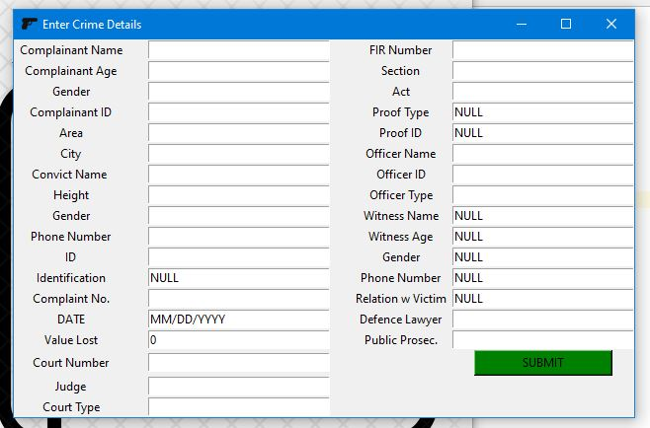

|  |  |  |
| --- | --- | --- |
| SI NO | PARAMETERS | MARKS |

|  |  |  |
| --- | --- | --- |
| USN | NAME | MARKS |